HOPE AND GLORY

The links are on the “euro class” webpage, so there is no need to copy them, just go to page and click on the links

Write a film review in three parts :
- facts about the film
- the synopsis
- your opinion about the genre

1) facts about the film….. http://en.wikipedia.org/wiki/Hope_and_Glory_(film)

1) Who directed the film? (name/nationality)
- Where does the title come from?
- Who is starring in it?
- When was it released?
- Did it get any awards?

- The story (the synopsis)
Remember the main characters: The Rohan family :
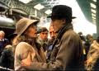
PARENTS - Father : ______________________ Mother : ______________________
CHILDREN- Girl 1: ______________ Girl 2 : _______________ Boy : ____________________

Who’s the narrator of the story ?

Use the questions to write the synopsis of the film:

When and where does the story take place?
Who are the characters? Who’s the narrator (so whose point of view is it?)
Where should Billy and his sister go? Why ? why does their mother change her mind twice?
At the beginning of the film, where does Billy’s father go? Who is Billy left with?
What do you think of Billy’s attitude to war ? (what does he “collect”? what does he compare the bombings to? What do Billy and his friends do after each bombing? What is the children attitude in school during the alert for instance?)
What happens to their house? Why is this ironic? Where does the family have to go?
What happens to his older sister? What sort of summer does Billy spend? What happens do his school in the end?

3) In the wikipedia article, Hope and Glory is said to be a comedy-drama: do you agree with that? Why? Why not?

The film and British history

* What did you learn about The British empire during the history lesson? (remember all the “pink” “pink” “pink” parts on the map?)

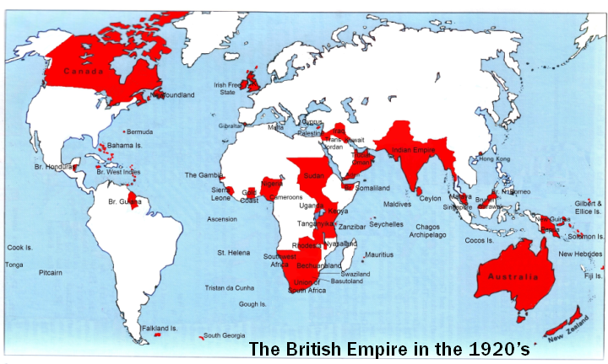

The British Empire was three quarters (3/4) – one half (1/2) – two fifths (2/5) – three eighths (3/8) of the world.

Comment upon this sentence by Queen Victoria : “The sun never sets on the British Empire.”

Quote some English colonies at the time :

The British empire as such doesn’t exist anymore: but some of its former members (54) are now part of an organization: do you know what it is called, and who is at the head of it?

* When the King delivers his Christmas speech on the radio, why is the language not fluid?
look it up here: http://www.historic-uk.com/HistoryUK/England-History/KingsandQueens.htm

What was the name of the King at that time?
What sort of man was he? What event did he want to take part in?
Who was his wife? Who’s his daughter?
